COST OF PARTICIPATION

PHARMA+BIO ASIA 2016 EXHIBITION
28 & 29 SEPTEMBER 2016
KUALA LUMPUR CONVENTION CENTRE

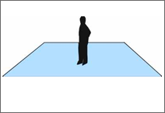 | OPTION 1 : RAW SPACE  RM1,000.00 (min. 18sq.m)  RM19,080* (Is inclusive of 6% GST)  Raw Space means floor space only and does not include any booth structure, construction, carpet, furniture, electrical fittings and all other forms of fittings. The exhibitor shall be responsible for his own stand design, construction, floor coverings and furnishings. Electrical fittings must be ordered from the official stand contractors.  This package includes the following:  - - 50 visitor invitation flyers  - - Daily booth cleaning services

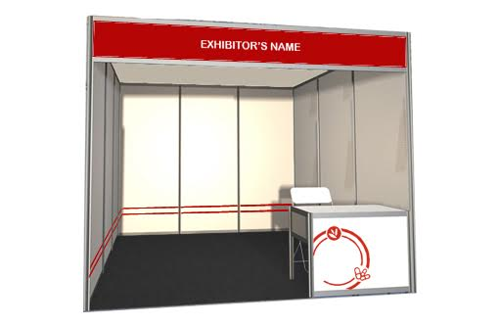 | OPTION 2 : SHELL SCHEME  RM1,150.00 (min 9 sq.m)  RM10,971 ( inclusive of 6% GST)  The Shell Scheme Rental Package includes:  - - Exhibition space  - - Information counter  - - 2 folding chairs  - - 1 (13 amp) power point  - - Needle punch carpet  - - 1 wastepaper basket  - - 2 fluorescent lights  - - 50 visitor invitation flyers  - - Daily booth cleaning

